**Knowledge Representation and reasoning**

AI-

We call the program intelligent if they exhibit behaviors that would be regarded intelligent if they were exhibited by the human beings.

-Herbert Simon

If you want to think of building intelligent **agent**, we should be able to represent the agent in which he is coming from (domain).

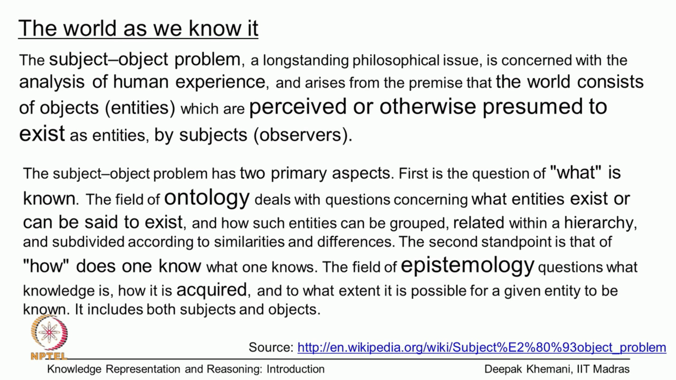

Ontology talks about the concepts such as “Light”, “chair”, “Books”.

Knowledge based systems are also called **Epistemology** systems.

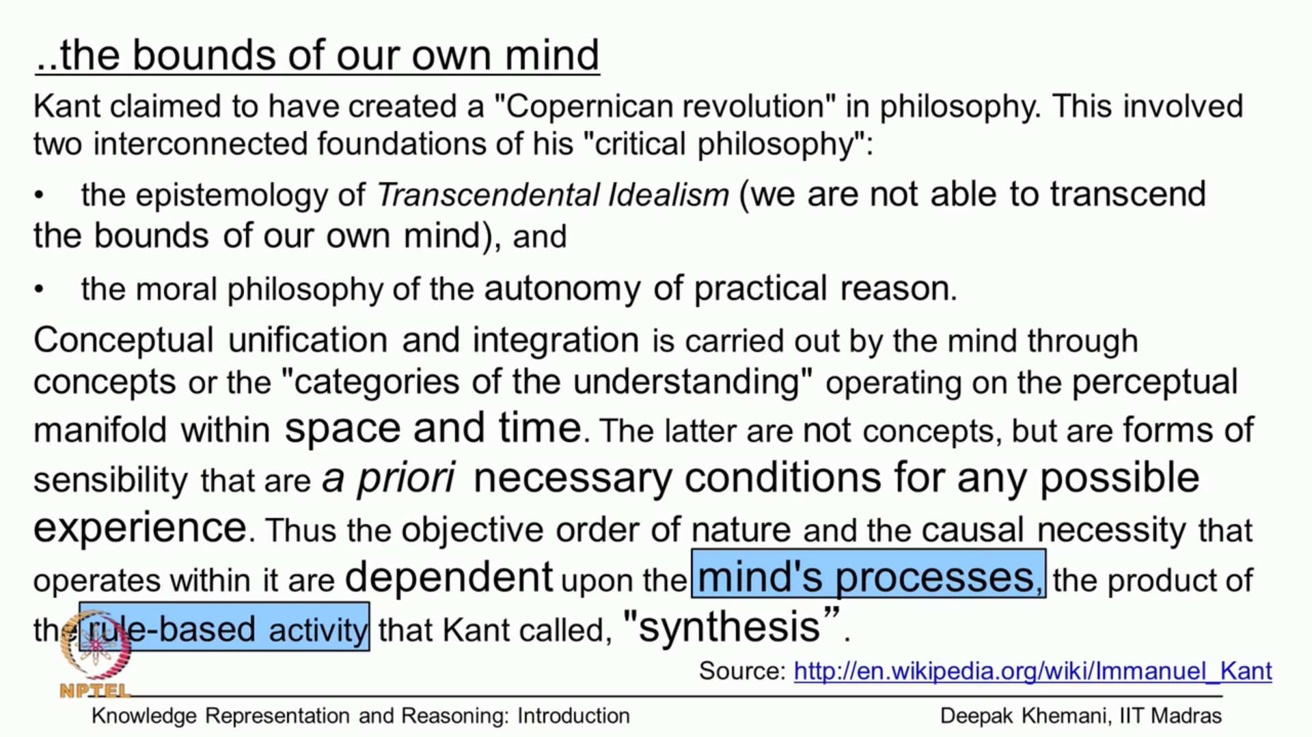

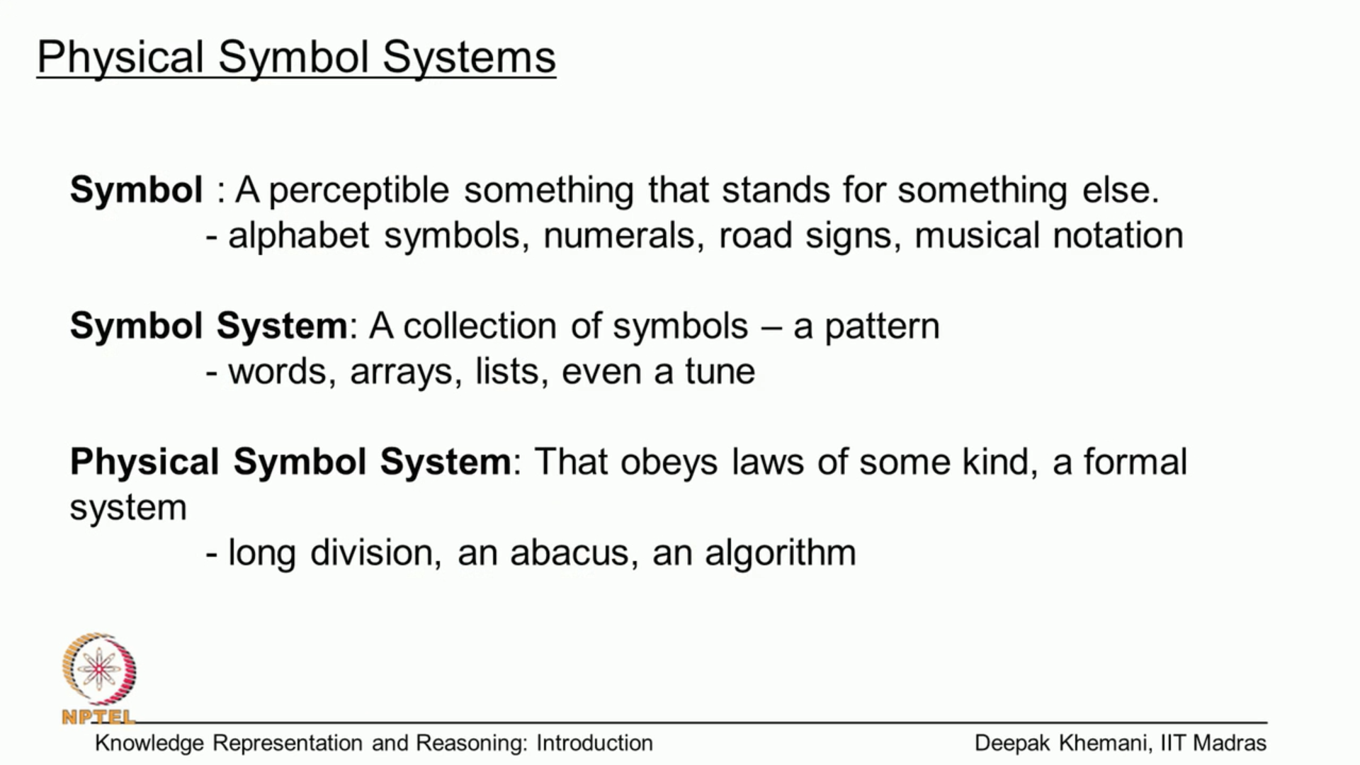

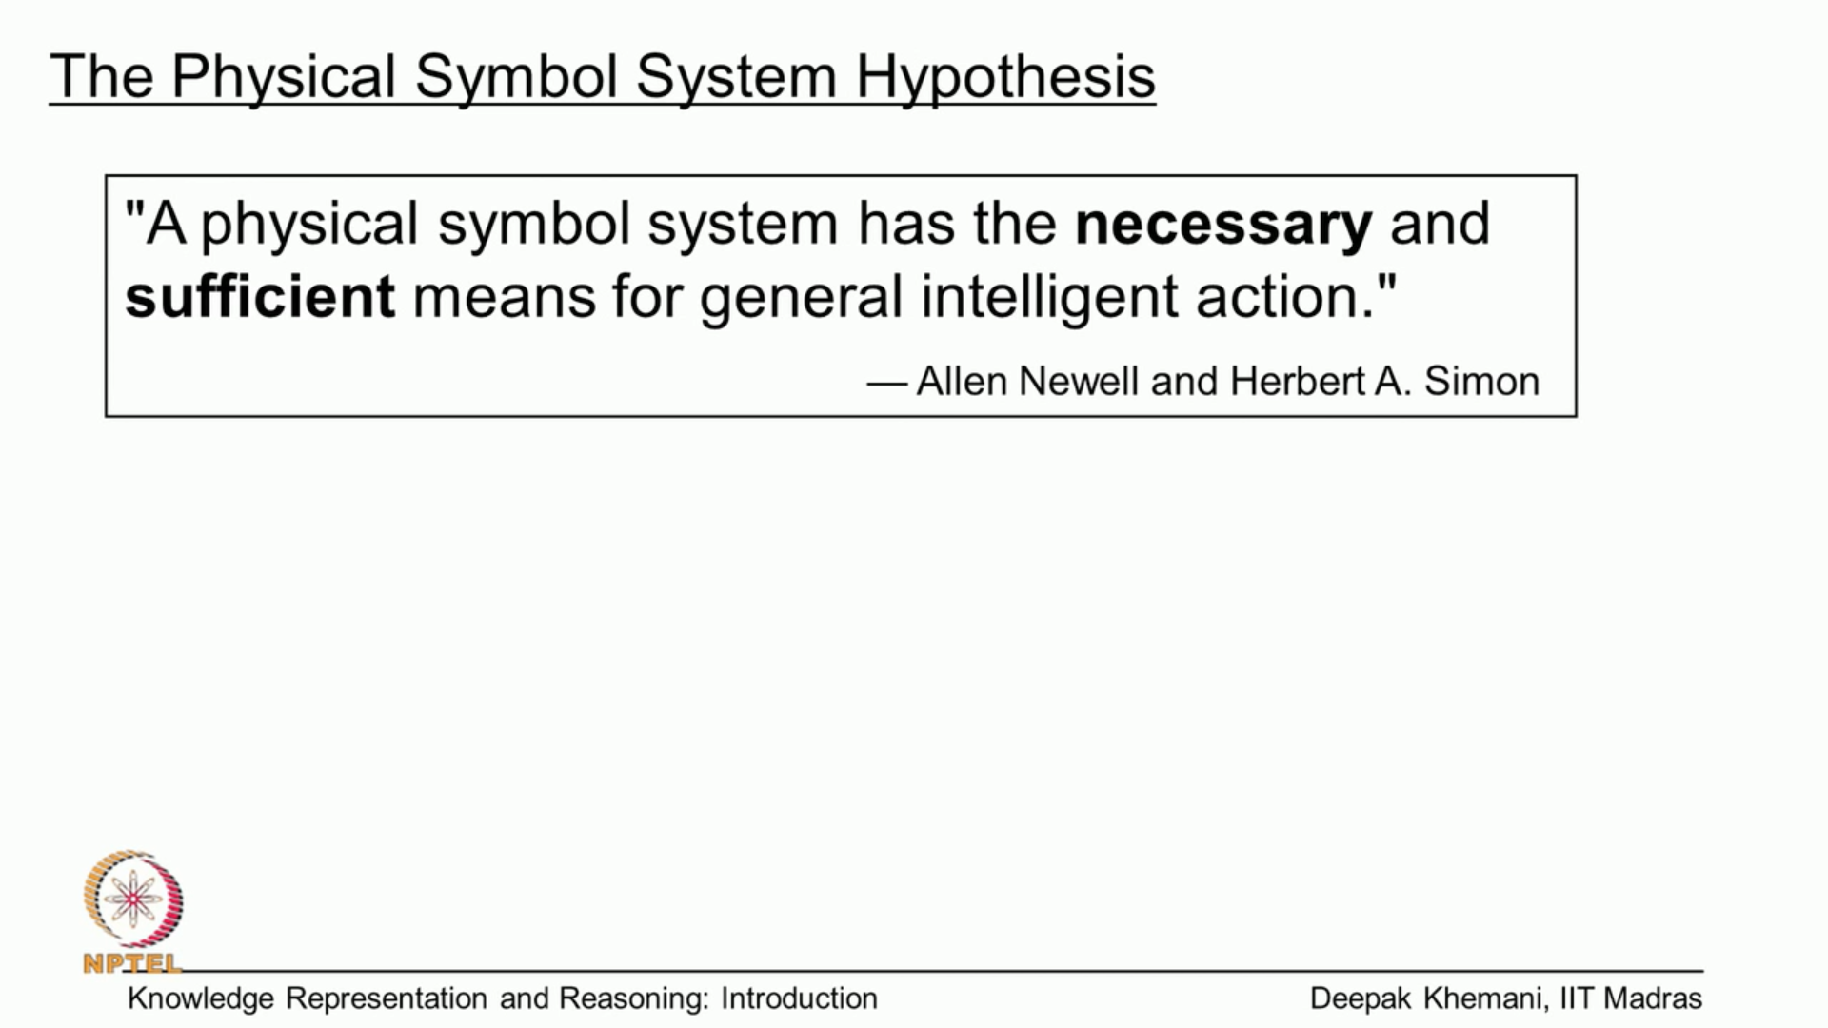

Ability to manipulate symbols – Symbolic AI/Classical AI

In neural network, we dont know have a representation. We dont know who to represent something. Somehow, complex network of neurons and relations will capture the concepts.

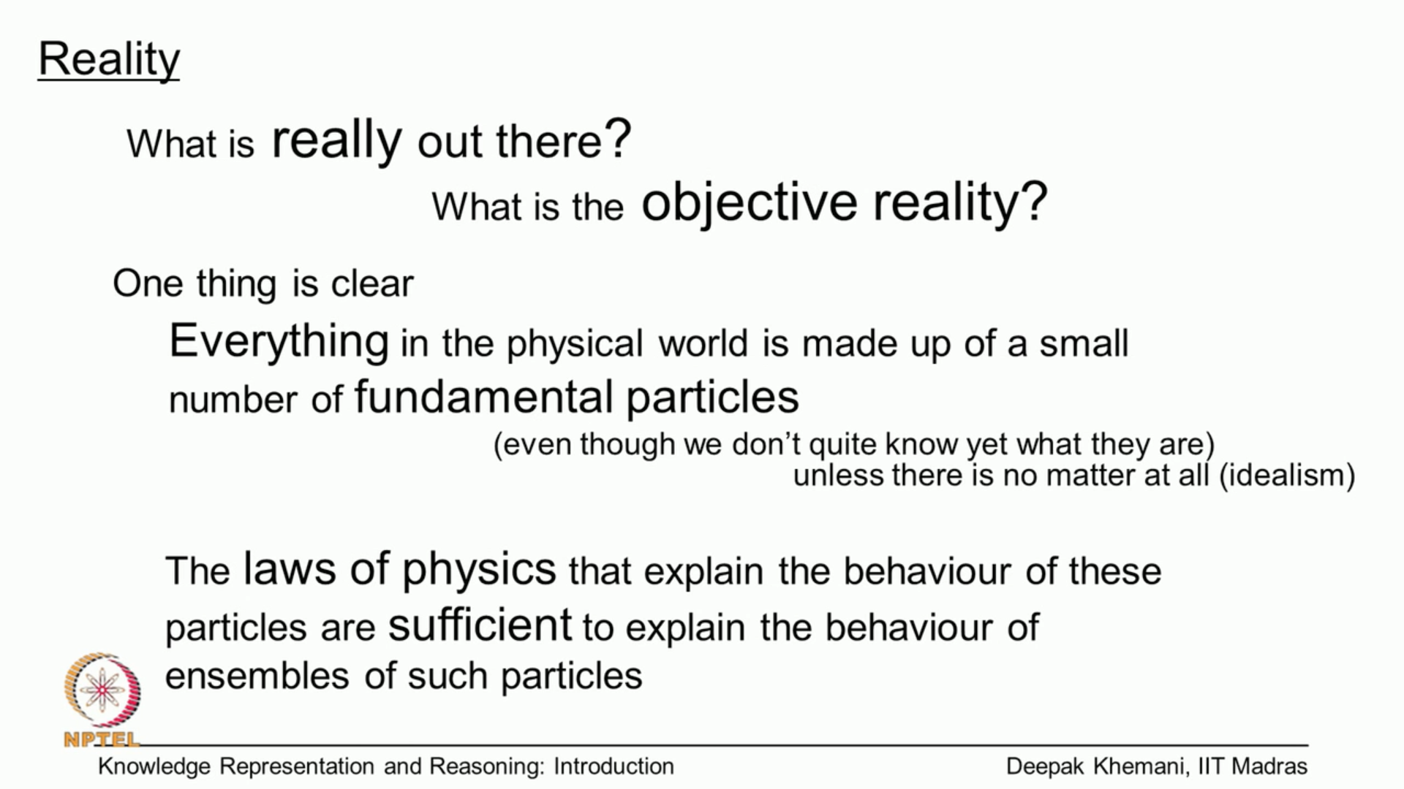

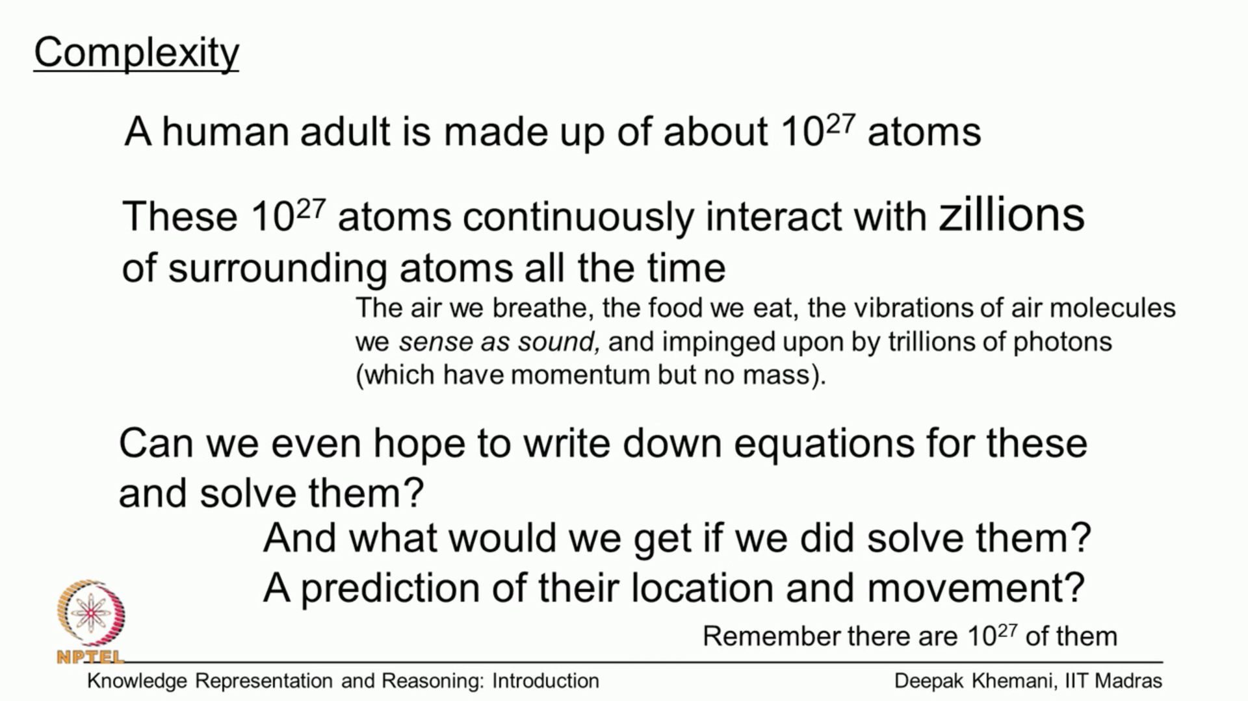

What we will get solving above? Will get prediction of allocation in movement

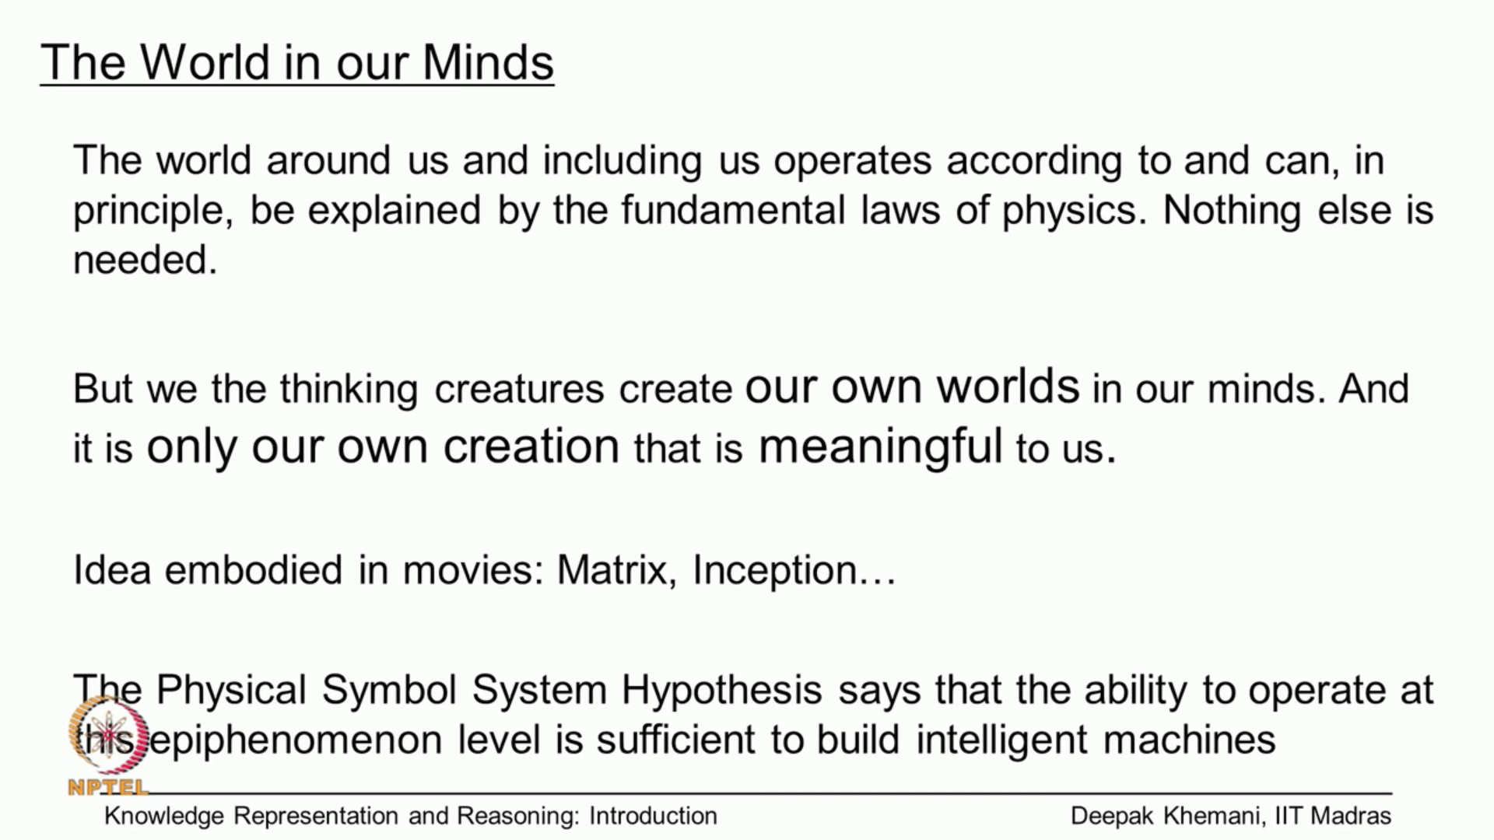

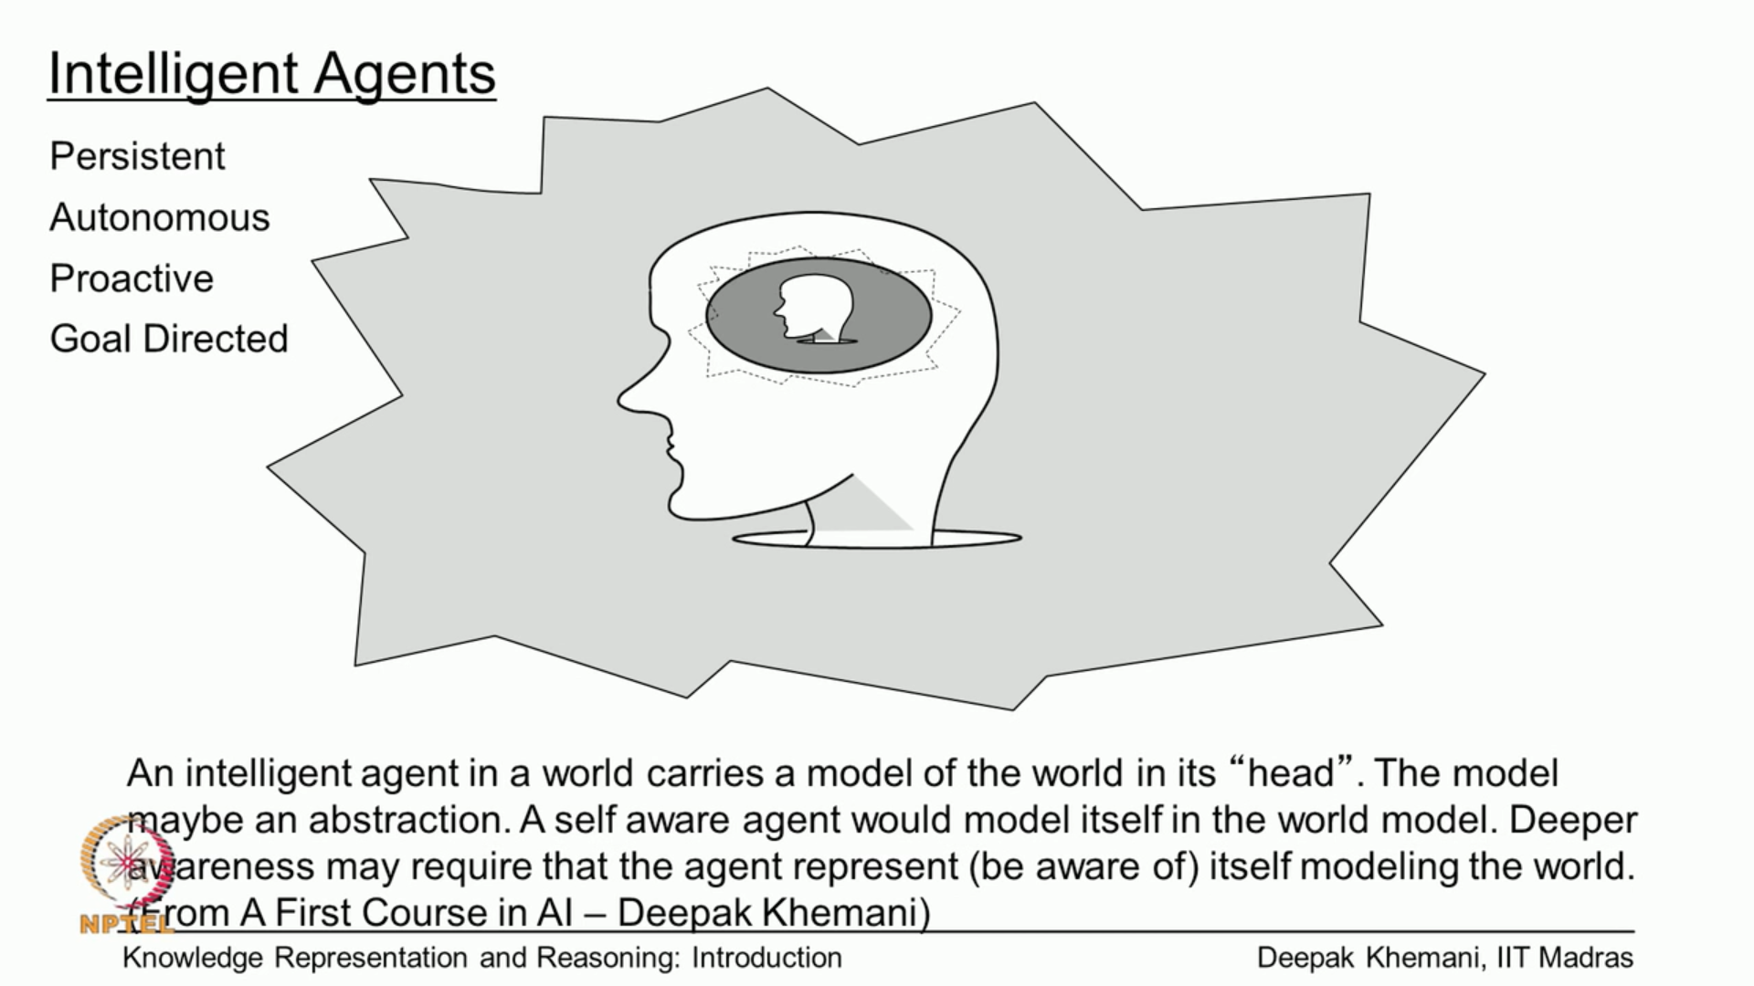

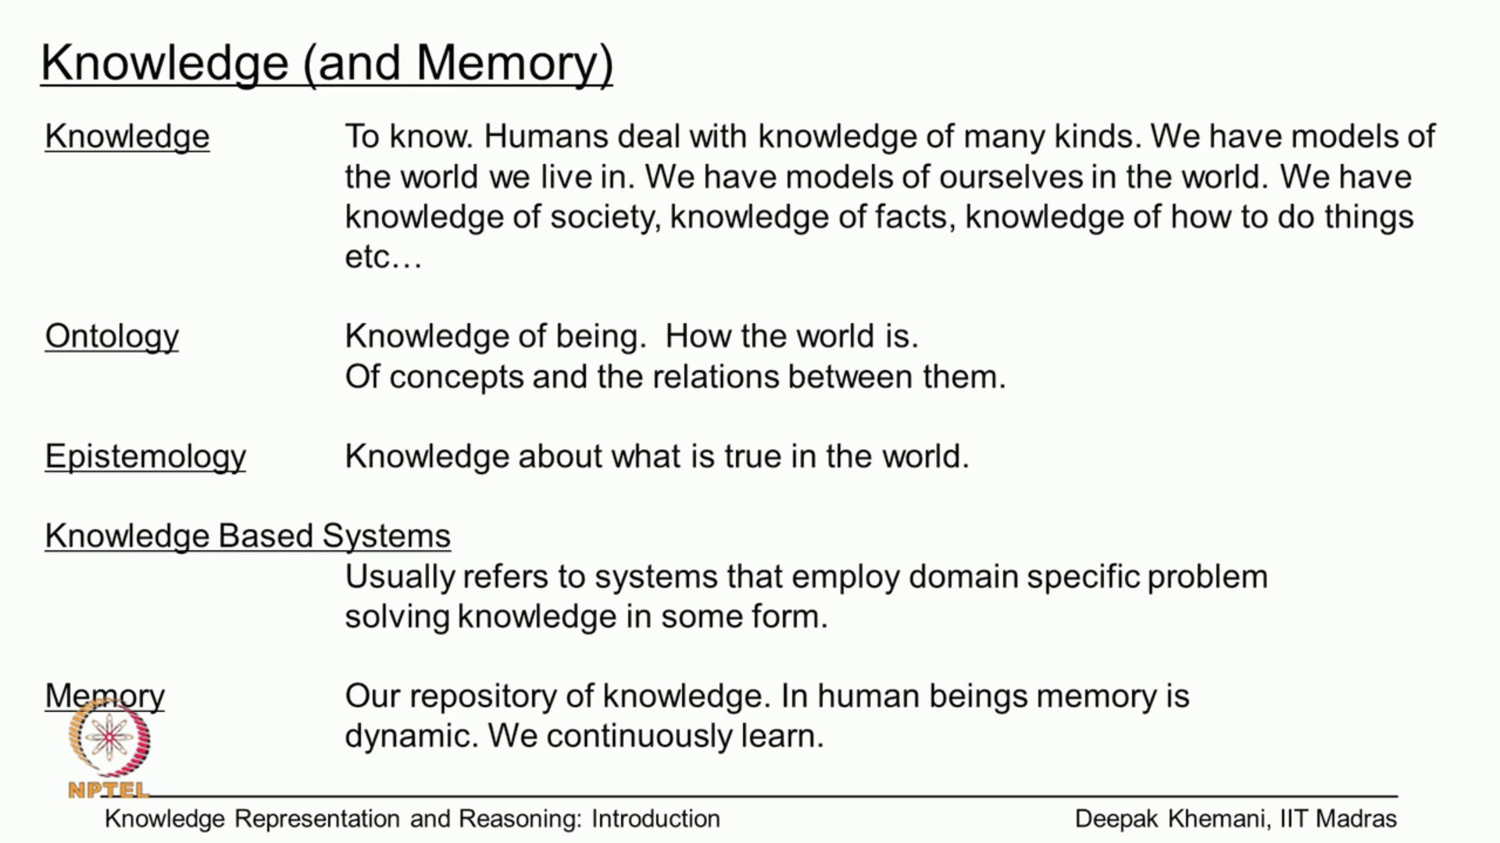

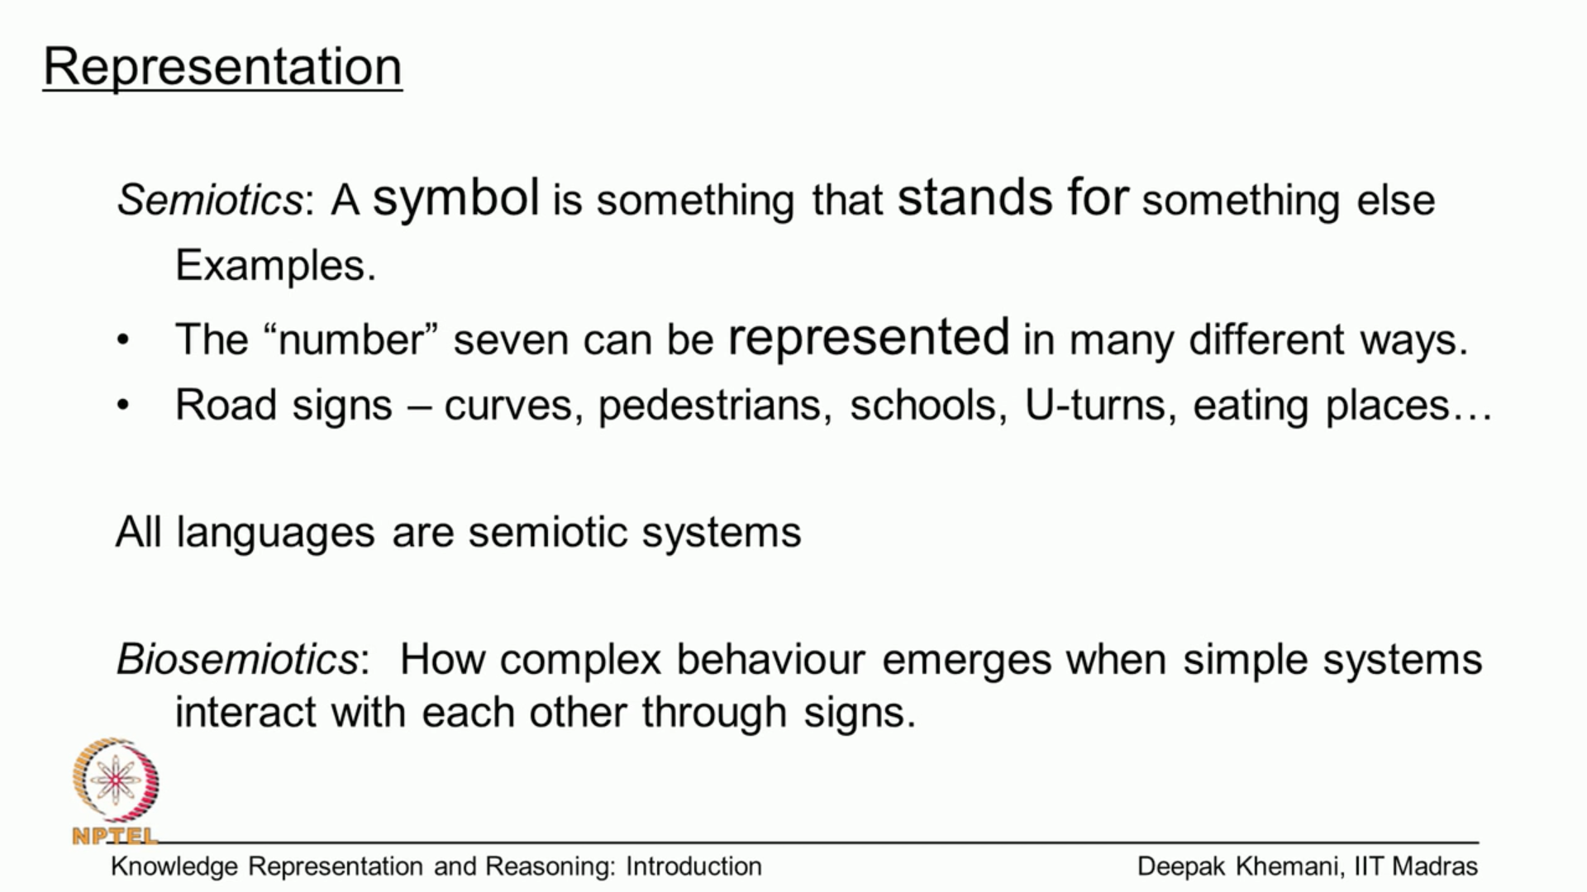

Formal Logic

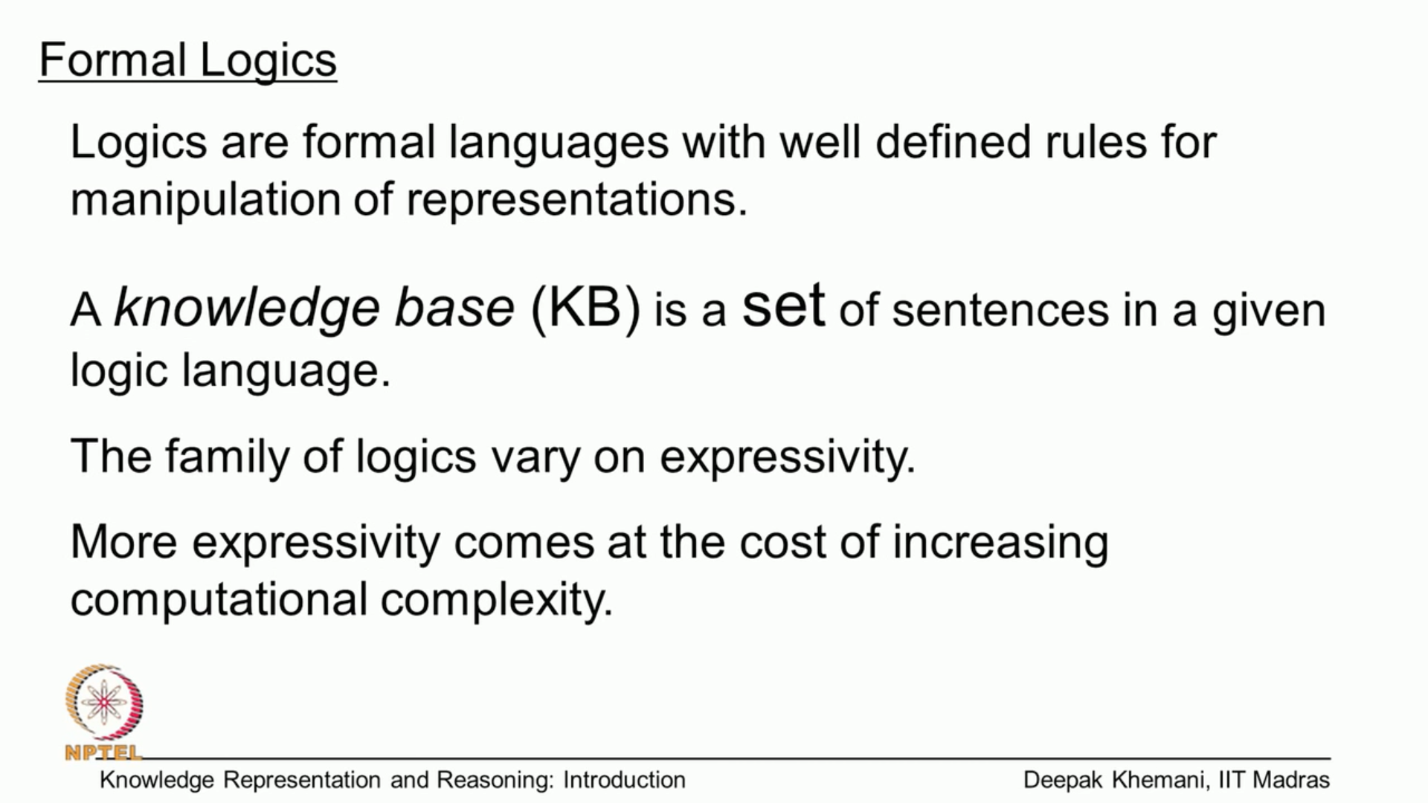

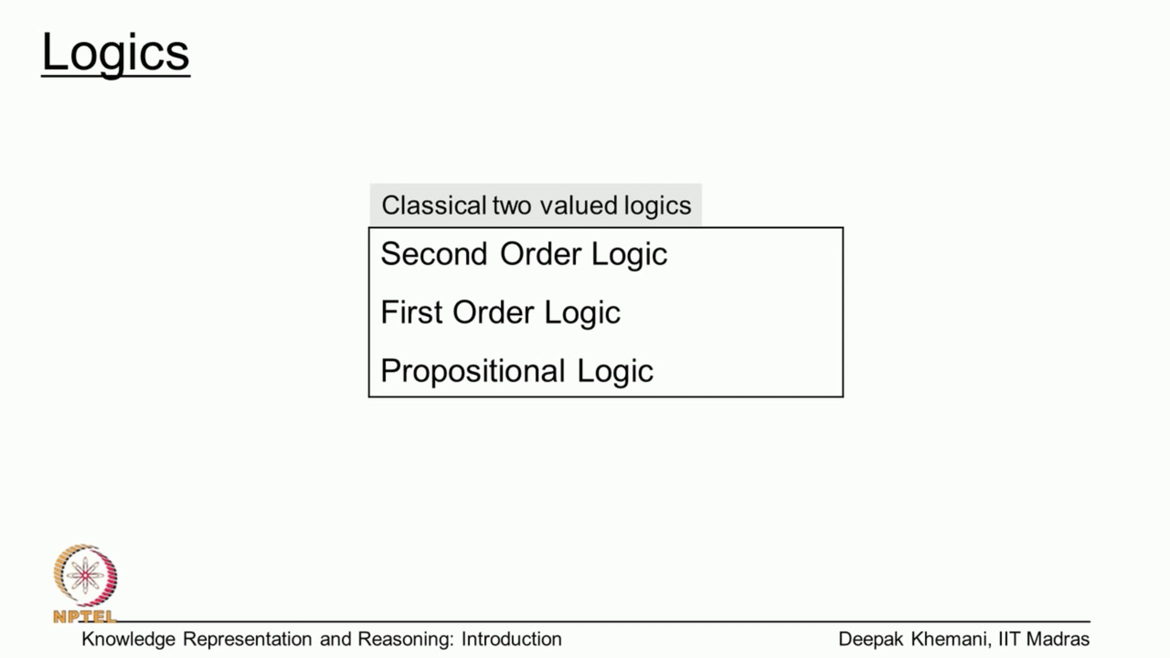

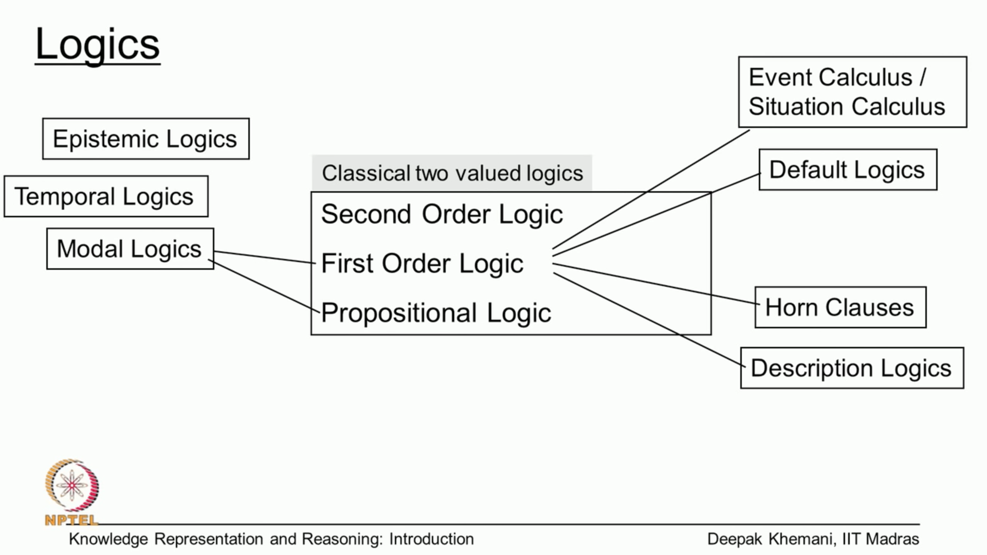

**How is the “Semantic Web” Different?**

The word semantic itself implies meaning or understanding. As such, the fundamental difference between Semantic Web technologies and other technologies related to data (such as relational databases or the World Wide Web itself) is that the **Semantic Web is concerned with the meaning** and not the structure of data.

**RDF:** RDF store (aka Triplestore)

RDF is a Data Model for describing “things” and their interrelations.

RDF consists of statements about “things” (e.x: customer /products, Web resources) in the form of subject-predicate-object expressions, also known as **triples**

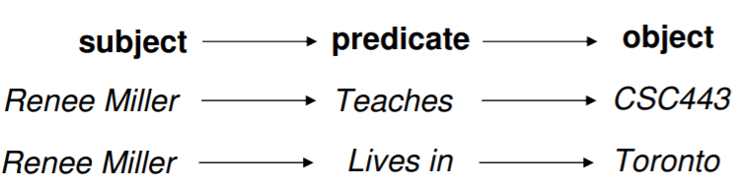

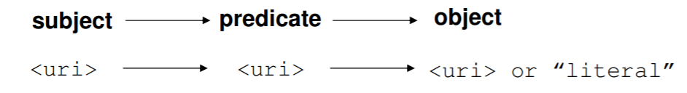



**Uniform Resource Identifier (URI):** a string of characters used to identify a name or a resource on the Internet.

NOTE: Some popular RDF stores include Sesame, Jena, Redland,

**Overview of graph embedding method**

We provide a brief overview of different graph embedding methods that are categorized into three groups:

* MF( Matrix Factorization)-based,
* random walk-based and
* neural network-based

1. **Matrix Factorization** has been widely adopted for data analyses. Essentially, it aims to factorize a data matrix into lower dimensional matrices and still keep the manifold structure and topological properties hidden in the original data matrix. ***Pioneer work in this category dates back to the early 2000s, such as Isomap (***[***Tenenbaum et al., 2000***](javascript:;)***), Locally Linear Embedding ([Roweis and Saul, 2000](javascript:;)) and LEs (***[***Belkin and Niyogi, 2003***](javascript:;)*). Traditional MF has many variants, such as singular value decomposition (SVD) and graph factorization (GF) (*[*Ahmed et al., 2013*](javascript:;)*).* And they often focus on factorizing the first-order data matrix (e.g. adjacency matrix).

More recently, researchers focus on designing various high-order data proximity matrices to preserve the graph structure and propose various MF-based graph embedding learning methods. For example, GraRep ([Cao et al., 2015](javascript:;)) considers the high-order proximity of the network and designs k-step transition probability matrices for factorization. HOPE ([Ou et al., 2016](javascript:;)) also considers the high-order proximity. But different from GraRep, it adopts some well-known network similarity measures such as Katz Index and Common Neighbors to preserve network structures.

1. **Random walk-based methods** Inspired by the word2vec model, a popular word embedding technique from Natural Language Processing (NLP), which tries to learn word representations from sentences, random walk-based methods are developed to learn node representations by **generating ‘node sequences’** through random walks in graphs. Specifically, given a graph and a starting node, random walk-based methods first select one of the node’s neighbors randomly and then move to this neighbor. This procedure is repeated to obtain node sequences. Then the word2vec model is adopted to learn embeddings based on the generated sequences of nodes. In this way, structural and topological information can be preserved into latent features.

One of the initial works in this category is DeepWalk ([Perozzi](javascript:;)*[et al.](javascript:;)*[, 2014](javascript:;)), which performs truncated random walks on a graph. Compared with DeepWalk, node2vec adopts a flexible biased random walk procedure that smoothly combines breadth-first sampling and depth-first sampling to generate node sequences. Furthermore, struc2vec ([Ribeiro *et al.*, 2017](javascript:;)) is proposed for better modeling the structural identity (e.g. nodes in the network may perform similar functions). Particularly, struct2vec first constructs a multi-layer weighted graph that encodes the structural similarity between nodes where each layer *k* is defined by using the *k*-hop neighborhoods of the nodes. Deep Walk is then performed on the multilayer graph to learn node representations in which nodes with high structural similarity are close to each other in the embedding space.

1. **Neural network-based methods:** Recent years have witnessed the success of neural network models in many fields. Various neural networks also have been introduced into graph embedding areas, such as multilayer perceptron (MLP) autoencoder, generative adversarial network (GAN) and graph convolutional network (GCN). Different methods adopt different neural architectures and use different kinds of graph information as input. For example, LINE Large-scale Information Network Embedding directly models node-embedding vectors by approximating the first-order proximity and second-order proximity of nodes, which can be seen as a single-layer MLP model. DNGR (Deep Neural Network for Graph Representation) applies the stacked denoising auto encoders on the positive pointwise mutual information (PPMI) matrix to learn deep low-dimensional node embeddings. SDNE adopts a deep autoencoder to preserve the second-order proximity by reconstructing the neighborhood structure of each node; meanwhile, it also incorporates LEs proximity measure into the learning framework to exploit the first-order proximity. GAE utilizes a GCN encoder and an inner product decoder to learn node embeddings. Graph GAN adopts GANs to model the connectivity of nodes. The GAN framework includes a generator and a discriminator where the generator approximates the true connectivity distribution over all other nodes and generates fake samples, while the discriminator model detects whether the sampled nodes are from ground truth or generated by the generator

**Applications of graph embedding on biomedical networks**

Link prediction tasks:

* DDA - drug-disease association prediction
* DDI - drug–drug interaction prediction
* PPI - protein–protein interaction prediction

Node classification tasks:

* Medical term **semantic type** classification
* Protein function prediction

We develop an easy-to-use Python package with detailed instructions, BioNEV (Biomedical Network Embedding Evaluation), available at: https://github.com/xiangyue9607/BioNEV, including all source code and datasets, to facilitate studying various graph embedding methods on biomedical tasks.

The results indicate that the graph embedding methods can achieve very competitive or better performance while being general (i.e. applied on different graphs and tasks). The learned embedding can also be treated as a complementary representation for the biological features. By summarizing the experimental results, we provide insightful observations as well as suggestions for selecting proper graph embedding methods and setting their hyper-parameters for biomedical prediction tasks. For instance, for MF-based methods, modeling highorder proximity (Cowen et al., 2017) [e.g. HOPE (Ou et al., 2016) and GraRep (Cao et al., 2015)] is more useful in biomedical link prediction tasks compared with node classification tasks. For random walk-based methods, DeepWalk (Perozzi et al., 2014) and node2vec (Grover and Leskovec, 2016) perform better in node classification tasks while struc2vec achieves better results in biomedical link prediction tasks. We also discuss the connections between embedding methods and the recent network propagation and diffusion methods in biomedical graph analysis (Cowen et al., 2017). Additionally, we illustrate a few new trends and directions (e.g. transfer learning in biomedical graph embedding) to encourage future work.

Knowledge Graph Embeddings: in order to predict missing relations in a knowledge graph, most algorithms rely on feature learning approaches that are able to map entities and relations into a vector space, generating knowledge graph embeddings.

Graph embedding learning that aims to automatically learn low-dimensional node representations has drawn increasing attention in recent years. To date, most recent graph embedding methods are evaluated on social and information networks and are not comprehensively studied on biomedical networks under systematic experiments and analyses. On the other hand, for a variety of biomedical network analysis tasks, traditional techniques such as matrix factorization (which can be seen as a type of graph embedding methods) have shown promising results, and hence there is a need to systematically evaluate the more recent graph embedding methods (e.g. random walk-based and neural network-based) in terms of their usability and potential to further the state-of-the-art.

**Introduction**

To analyze the graph data, a surge of graph embedding *(a.k.a. network embedding or graph representation learning)* methods have been proposed, where their goal is to automatically learn a low-dimensional feature representation for each node in the graph.

Intuitively, the low-dimensional representations are learned to preserve the structural information of graphs, and thus can be used as features in building machine learning models for various downstream tasks, such as link prediction, community detection, node classification and clustering. However, to date, these advanced approaches are mainly evaluated on non-biomedical networks such as social networks, citation networks, and user-item networks, and only a few studies provide evaluations and analyses on biomedical networks.

**Results**: We select 11 representative graph embedding methods and conduct a systematic comparison on 3 important biomedical link prediction tasks: drug-disease association (DDA) prediction, drug–drug interaction (DDI) prediction, protein–protein interaction (PPI) prediction; and 2 node classification tasks: medical term semantic type classification, protein function prediction. Our experimental results demonstrate that the recent graph embedding methods achieve promising results and deserve more attention in the future biomedical graph analysis. Compared with three state-of-the-art methods for DDAs, DDIs and protein function predictions, the recent graph embedding methods achieve competitive performance without using any biological features and the learned embeddings can be treated as complementary representations for the biological features. By summarizing the experimental results, we provide general guidelines for properly selecting graph embedding methods and setting their hyper-parameters for different biomedical tasks.

##### **1. Graph Traversal**

**Finding the shortest path**

Find a path between two vertices in a graph whose sum of the weights of its edges is minimized. There are many algorithms to solve this problem: Dikstra, A*, Bellman-Ford, Floyd-Warshall, etc.

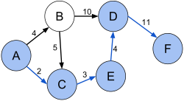

Feature 1. Shortest path between vertices A and F (pic from wikipedia.org)

**Graph Distance**

* Eccentricity  
  E(v) of vertex v is the greatest distance between v and any other vertex.
* Radius  
  r of a graph is the minimum eccentricity of any vertex.
* Diameter  
  **d** of a graph is the maximum eccentricity of any vertex.

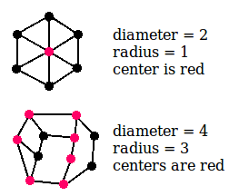

Feature 2. Graph distance

##### **2. Centrality**

* **Closeness**  
  Closeness centrality is defined as the reciprocal of the sum of the shortest path distances of a node to all other nodes in the graph. Therefore, a node with high closeness centrality has short distances to all other nodes of a graph. The algorithm [ClosenessCentrality](https://docs.yworks.com/yfiles-html/api/ClosenessCentrality.html) supports both directed and undirected edges and optional edge weights.
* **Betweenness**  
  The number of times a node acts and a bridge along the shortest path between two other nodes.
* **Degree**  
  The number of direct neighbors
* **Eigenvector**  
  The relative scores to all nodes in the network based on the concept that connections to high-scoring nodes contribute more to the score of the node in question than equal connections to low-scoring nodes.

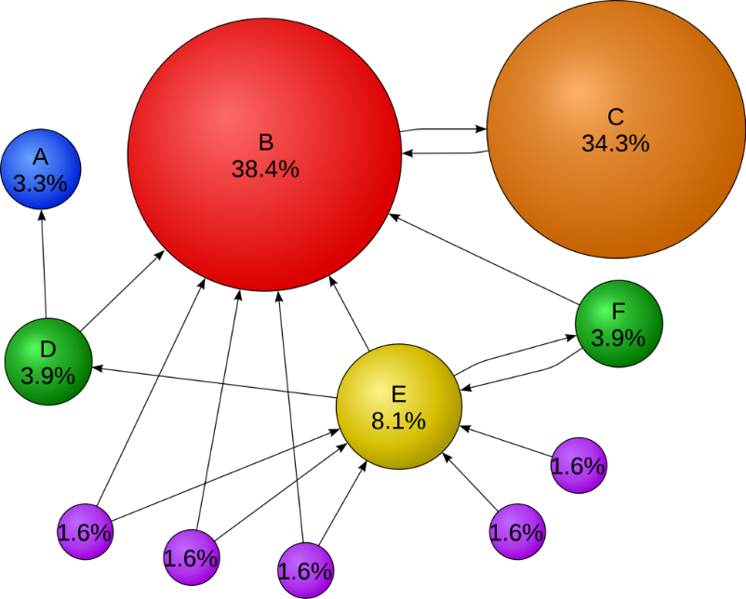

Feature 3. Pagerank is a variant of the eigenvector centrality measure (pic from wikipedia.org)

Personalizing search

Two general ways of personalizing search

1. Query Expansion
2. Reranking (BM25 scoring)

We curate the world information in the form of graph.

All the technologies are based on Semantic Web technologies is the basis for KG

KG- Is the web of data

### **Applications:**

### **3.1 Link prediction**

### Discovering new interactions (links) is one of the most important tasks in the biomedical area. A considerable amount of efforts has been devoted to developing computational methods to predict potential interactions in various biomedical networks, such as the DDA network, DDI network and PPI network. Developing such computational methods can help generate hypotheses of potential associations or interactions in biological networks.

### The link prediction task can be formulated as: given a set of biomedical entities and their known interactions, we aim to predict other potential interactions between entities. Traditional methods in the biomedical field put much effort on feature engineering to develop biological features [e.g. chemical substructures, gene ontology or graph properties [e.g. topological similarities. After that, supervised learning methods [e.g. support vector machine (SVM), Random Forest] or semi-supervised graph inference model e.g. label propagation are utilized to predict potential interactions. The assumption behind these methods is that entities sharing similar biological features or graph features could have similar connections.

### However, deploying methods based on biological features typically faces two problems: (i) biological features may not always be available and can be hard and costly to obtain. One popular approach to solve this problem is to remove those biological entities without features via pre-processing, which usually results in small-scale pruned datasets and thus is not pragmatic and useful in the real setting. (ii) Biological features, as well as hand-crafted graph features (e.g. node degrees), may not be precise enough to represent or characterize biomedical entities, and may fail to help build a robust and accurate model for many applications.

### Graph embedding methods that seek to learn node representations automatically are promising to solve the two problems mentioned above. Embedding ideas have also been employed in some recently proposed computational methods in the biomedical field. For example, MF-based techniques are used for predictions of DDAs. Essentially, a DDA matrix is factorized to learn low-dimensional representations for drugs and diseases in the latent space. During factorization, regularization terms or constraints can be added to further improve the quality of latent representations. For predictions of DDIs, propose manifold regularized MF in which Laplacian regularization is incorporated to learn a better drug representation. Besides, graph neural network is introduced for DDIs prediction and the intuitions are similar to the GAE. PPIs are commonly predicted using Laplacian and SVD techniques propose an autoencoder-based model to learn embeddings of proteins, which has a similar design to SDNE.

### **3.2 Node classification**

### In addition to the link prediction task, node classification which aims to predict the class of unlabeled nodes given a partially labeled graph, is also one of the most important applications in graph analyses. Here, we mainly focus on two node classification applications: protein function prediction and medical term semantic type classification.

### Protein function prediction. The large-scale experimental functional annotation of proteins is often expensive, hence graph-based computational methods which widely incorporate the idea of graph embedding, have been proposed in recent years. For example, propose a regularized Laplacian kernel-based method to learn low-dimensional embeddings of proteins. Cho develop Mashup, which first performs random walks with restart (RWR) on PPI networks and then learns embeddings for each protein via a low rank matrix approximation method (can be optimized by SVD). The feature vectors are then fed into classifiers to derive functional insights about genes or proteins.

### [Kulmanov et al. (2018)](javascript:;) propose DeepGO that learns joint representations of proteins based on protein sequences as well as PPI network via convolutional neural nets and a graph embedding method. In node2vec, [Grover and Leskovec (2016)](javascript:;) test the effectiveness of the proposed embedding method on a PPI network. Furthermore, [Zitnik and Leskovec (2017)](javascript:;) develop OhmNet, which optimizes hierarchical dependency objectives based on node2vec to learn feature representations in multi-layer tissue networks for function prediction. [Gligorijević et al. (2018)](javascript:;) develop deepNF, which learns embeddings of proteins via a deep autoencoder.

### **Medical term semantic type classification**. In the past few years, the increase of clinical texts have been encouraging data-driven models for improving the patient personal care and help clinical decision. However, due to the privacy and security concerns, the access to *raw clinical texts* is often limited. To facilitate research on clinical texts, a popular substitute strategy for releasing raw clinical texts is to extract medical terms and their aggregated co-occurrence counts from the clinical texts. However, such released privacy-aware datasets only contain medical terms (words or phrases) extracted from clinical texts and do not reveal the semantic information (e.g. semantic types or categories). By referring to some medical knowledge bases, e.g. unified medical language system (UMLS), we can obtain semantic types (labels) medical terms. But due to mismatch and incomplete knowledge in UMLS, the semantic types of some medical terms remain unknown. Hence, we formulate a less-investigated but meaningful node classification task.

### 

([Fig. 2](javascript:;)): given a medical term co-occurrence graph where terms and co-occurrence statistics have been extracted from clinical texts, classify the semantic types of medical terms. In this work, we assume the clinical texts have been converted into a medical term–term co-occurrence graph as in [Finlayson et al. (2014)](javascript:;), where each node is an extracted medical term and each edge is the co-occurrence count of two terms in a context window. We apply graph embedding methods to the co-occurrence graph to learn representations of medical terms. Afterward, a multi-label classifier can be trained based on the learned embeddings to classify the semantic types of medical terms.

# **Furthermore, we have the following key observations and analyses:**

* For the MF-based methods, since HOPE and GraRep are designed to capture the high-order proximity of graphs, they are usually more effective than traditional MF methods that only preserve the first-order of networks.
* For the random walk-based methods, generally, struc2vec performs better than DeepWalk and node2vec. This is because compared with DeepWalk and node2vec, struc2vec constructs a hierarchy weighted graph to measure the structural identity. Such hierarchy structure design incorporates both node degree distributions from the bottom as well as the entire network on the top, which can better capture the graph structure information and hence obtain better performance.
* For the neural network-based methods, LINE achieves competitive prediction performance consistently when compared with the best performing method on each dataset. It indicates that directly modeling edge information by a single-layer MLP is an effective way to learn node embeddings. SDNE and GAE also obtain satisfying prediction performance, which demonstrates that autoencoders and GCNs can also be useful for capturing graph structural information.

**4 Experiments**

In this section, we introduce the details of seven compiled datasets, including two DDA graphs, a DDI graph, a PPI graph for link prediction and a medical term–term co-occurrence graph as well as two PPI graphs for node classification. Then, we conduct comprehensive comparisons of 11 selected graph-embedding methods on these compiled datasets.

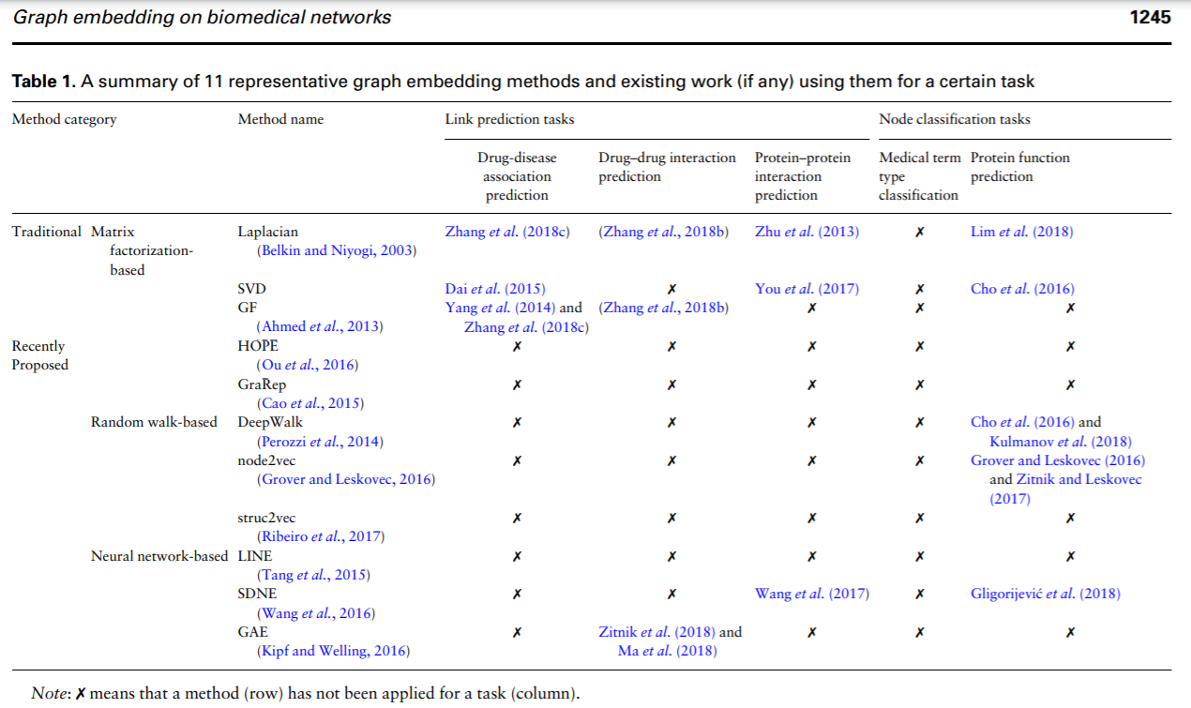

DDI graph. We collect verified DDIs from DrugBank (Wishart et al., 2018 ), a comprehensive and freely accessible online database that contains detailed information about drugs and drug targets.

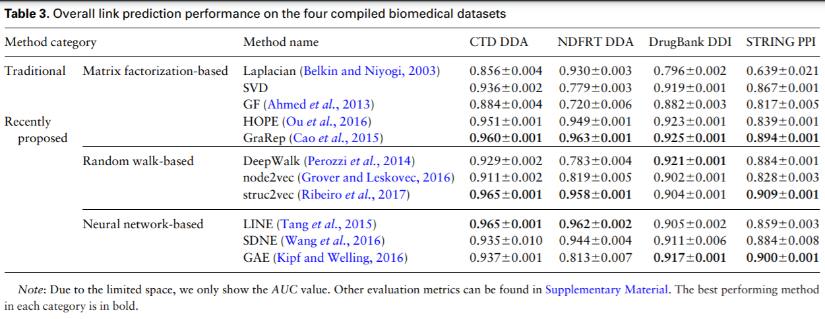

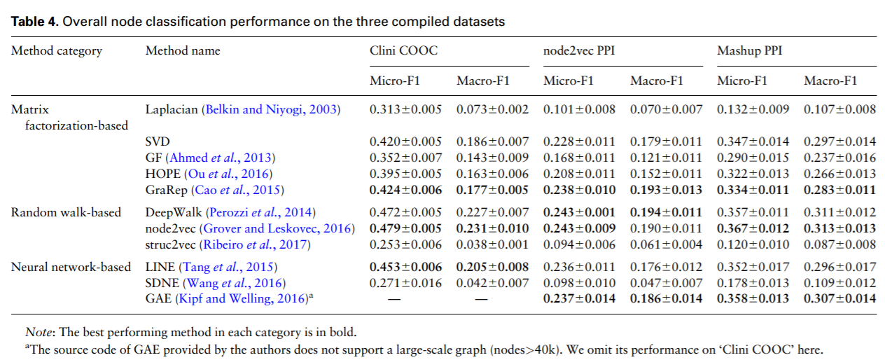

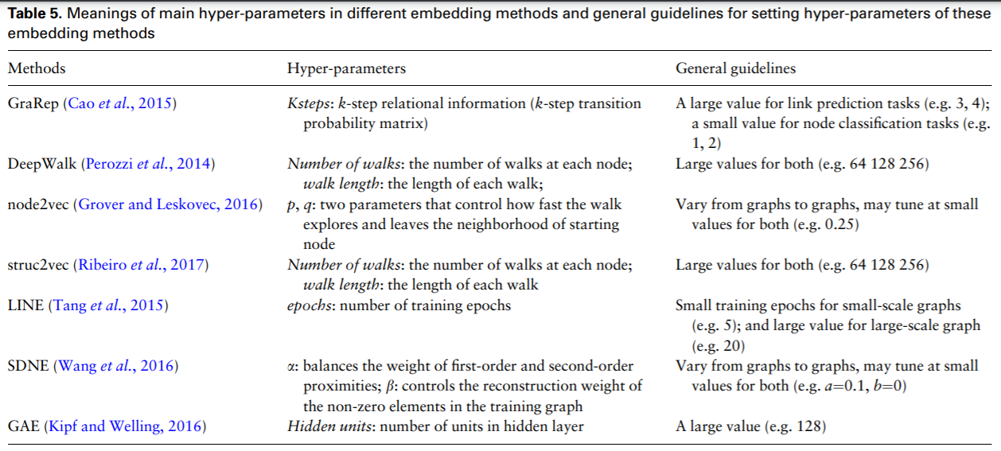

# **Verify the Embeddings**

I use two approaches to validate that the product embeddings are meaningful.

The first one is **cosine similarity** from pairs of d-dimensional vectors. For example, as we know, the similarity between an iPhone X and Samsung galaxy should be higher than the similarity between an iPhone X and a chair.

The second approach is to use [t-SNE](https://en.wikipedia.org/wiki/T-distributed_stochastic_neighbor_embedding) to visualize the Embeddings. What we can expect is the similar products should be closer in the embedding space. As we can see, it is obviously true. So we can conclude that the embeddings can be used to efficiently calculate the similarities between products, and we can use them as input for our neural networks (not the NN where we get the embeddings, but the NN for personalized outputs.)

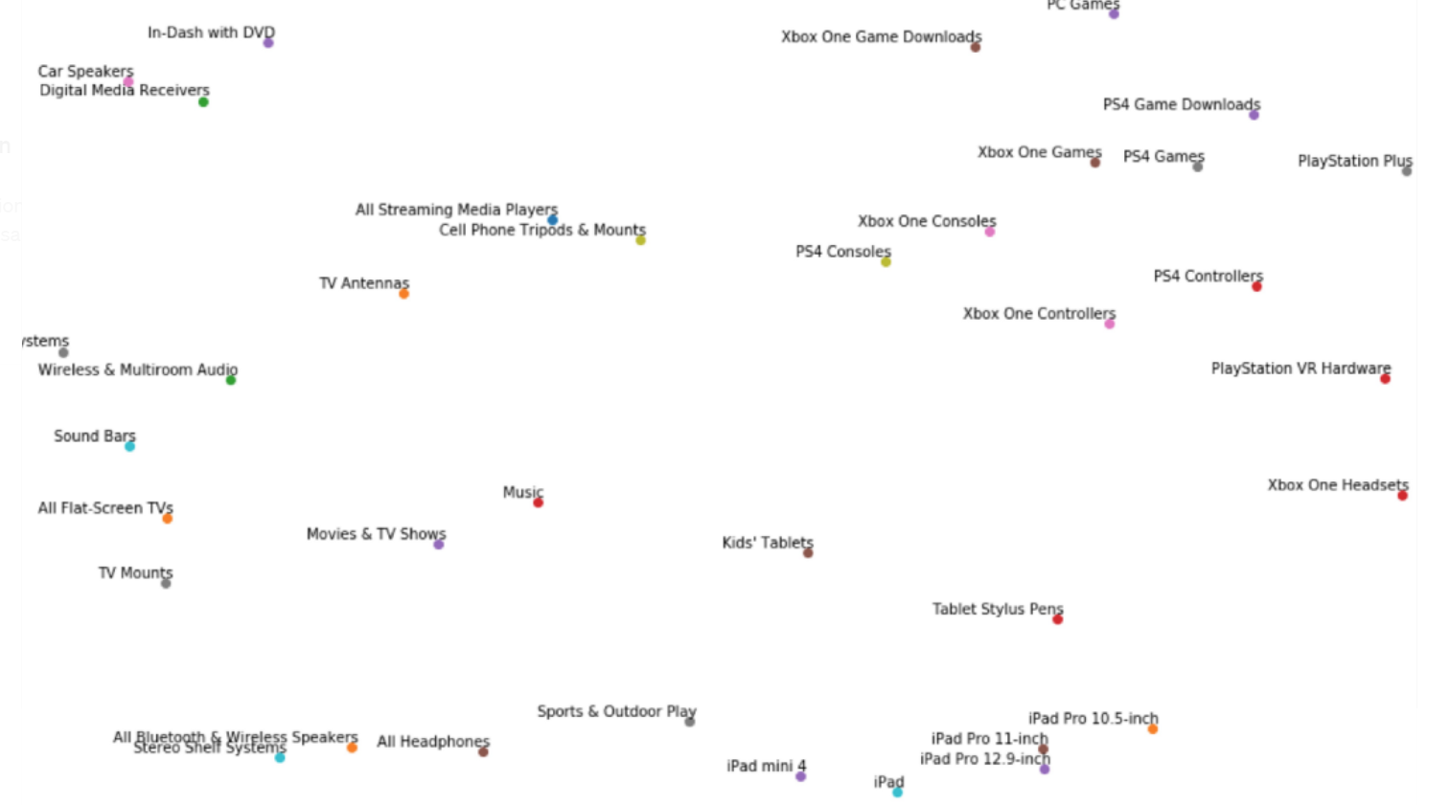

Part of product embeddings visualization

-TransE [3]: learns representations of entities and relations so that h + l ≈ t where (h, l, t) ∈ R is a triple. The score function for a triple is thus f(h, l, t) = d(h + l, t) where d is the Euclidean distance.

-TransH [14]: first extension of TransE, enables entities to have different representations when involved in different relations by projecting entities on a hyperplane identified by the normal vector wl . The score function becomes: f(h, l, t) = d(h⊥ + l, t⊥), where h⊥ = h − w T l hwl and t⊥ = t − w T l twl .

-TransR [9]: enables entities and relations to be embedded in vector space with different dimensions through a projection matrix Ml associated to any relation l. The score function is: f(h, l, t) = d(hl+l, tl) where hl = hMl and tl = tMl.

# **Use Embeddings to power Personalization**

We should put the customer information into the model to get personalized recommendations, and we can aggregate user’s browsing history by taking a time-decay weighted average of the d-dimensional product embeddings, with the assumption that the recent products play a more important role for customer’s final decision than those that customers viewed a long time ago.

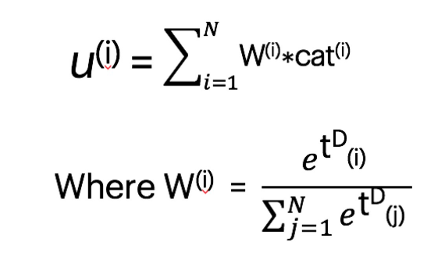

The weights here are a softmax probability on time calculated by the formula in the left. D is a parameter controlling how important the recent events are, and t is a function of the time period between the current time and the past event time.

I use Apache Airflow to get user embeddings from raw clickstream data and pre-trained product embeddings. After four BigQueryOperator tasks, I export the processed embeddings to Google Cloud Storage for the modeling part.

After having the user embeddings, we can feed them into the neural networks for a recommendation**. The target is the most recent product for each user,** and the features are user embeddings obtained from any product embeddings except the most recent one for this user. I use dense layers with ReLu activation functions, followed by Dropout layers and BatchNormalization Layers. The final layer is a softmax with M-class classifications, where M is a number of unique products in our trained embeddings.

I conducted offline experiments with several metrics like next-add-to-cart hit rate, mean reciprocal rank, and there is a significant improvement from this model compared with current models.

[Embeddings at E-commerce. Power personalization with deep… | by Louis Wang | DataDrivenInvestor](https://medium.datadriveninvestor.com/embeddings-at-best-buy-fc081efa374f)